OUR MOST BEAUTIFUL MOMENT IN LIFE
Beyond the stage, beyond the spotlight – just seven boys creating memories together.
Behind every powerful performance, every award, and every unforgettable song, there are seven individuals who share something much more personal – a lifetime of memories.
We have seen BTS as global superstars, but their reality shows have allowed us to see another side of them: seven friends laughing over silly jokes, competing over the smallest things, cooking together, travelling to unfamiliar places, supporting one another, and simply enjoying each other's company.
Through these moments, we discovered that their bond goes far beyond music. It is found in their playful arguments, unexpected teamwork, shared meals, late-night conversations, spontaneous laughter, and the little things they do for one another.
From their early adventures to peaceful vacations, every show has captured a different chapter of their journey. And perhaps the most beautiful part is that they never needed a grand stage to create unforgettable memories. Sometimes, all they needed was each other.

01. RUN BTS!
Seven Members. Endless Chaos. Unlimited Laughter.
Run BTS! is one of the most loved variety shows among ARMY. It brings out the playful, competitive, and hilarious sides of all seven members.
From hilarious cooking challenges and sports competitions to mystery games, treasure hunts, quizzes, and unexpected punishments, every episode creates unforgettable memories.
Some memorable moments to highlight:
- The members' hilarious cooking experiments and kitchen disasters.
- Their competitive sports and athletic challenges.
- The legendary betrayal, cheating accusations, and dramatic reactions during games.
- Their teamwork during treasure hunts and escape-room challenges.
- The 100th episode celebration and their nostalgic moments together.
A little thought:
"Sometimes the best memories are not planned. They happen when seven people forget the cameras and simply enjoy being together."
02. BTS BON VOYAGE
The World Was Their Playground.
Bon Voyage gave BTS the opportunity to travel together and experience different cultures, places, and adventures.
Across four seasons, the members travelled to Northern Europe, Hawaii, Malta, and New Zealand. From getting lost and managing their luggage to exploring beautiful destinations, preparing meals, and enjoying spontaneous adventures, the show captured their friendship in its most natural form.
Some memorable moments to highlight:
- Their first travel adventures and learning to manage things independently.
- The beautiful landscapes and unforgettable experiences in Malta.
- Their hilarious travel mishaps and unexpected situations.
- Sharing food, exploring new places, and spending time together.
- The emotional goodbyes at the end of their journeys.
A little thought:
"It was never just about the places they visited; it was about the people who made every place feel like home."
03. IN THE SOOP BTS VER.
A Little Escape From the World.
In the SOOP means being in the forest. Unlike their usual busy schedules, this show allowed the members to slow down, relax, and enjoy their personal interests.
Away from the pressure of performances and schedules, they spent their days cooking, fishing, painting, playing games, making music, and enjoying peaceful moments together.
Some memorable moments to highlight:
- Jin enjoying fishing and cooking.
- SUGA spending peaceful time with music.
- RM enjoying nature and his personal hobbies.
- V enjoying music and relaxing moments.
- Jung Kook cooking and enjoying his activities.
- Jimin and j-hope sharing playful and heartwarming interactions.
- All seven members gathering around the table, sharing food and conversations.
A little thought:
"In a world that constantly asks them to shine, In the SOOP gave them a moment to simply be themselves."
04. AMERICAN HUSTLE LIFE
Where Their Journey Took Another Turn.
American Hustle Life was an early reality series from 2014 that followed BTS during their time in Los Angeles.
The show introduced the members to different aspects of hip-hop culture through various missions, experiences, and training sessions. It captured their younger personalities, determination, awkward moments, and growing confidence.
Memorable aspects:
- Their first experiences exploring Los Angeles.
- Learning about hip-hop culture.
- Their dance and music-related challenges.
- The members supporting each other through unfamiliar experiences.
- Seeing how much they have grown since their early debut days.
A little thought:
"Looking back at where they started makes every step of their journey even more meaningful."
05. BTS MONUMENTS: BEYOND THE STAR
Nine Years of Dreams, Struggles and Memories.
This documentary series takes ARMY through BTS's journey, from their beginnings to their global success.
It includes personal memories, important milestones, challenges, and moments that shaped them as artists and individuals.
It reminds us that behind every achievement, there are years of hard work, sacrifices, and countless memories.
A little thought:
"We didn't just witness their success; we witnessed the story behind it."
:::
06. OTHER LITTLE MEMORIES WORTH REMEMBERING
Show | What makes it special
Rookie King: Channel Bangtan | Their early rookie days and innocent chaos.
BTS GAYO | Music games, laughter and friendly competition.
BTS: Bon Voyage | Friendship through travel and adventure.
BTS: Break the Silence | Their personal thoughts and experiences on tour.
BTS: Burn the Stage | The hard work and emotions behind their performances.
BTS: Bring the Soul | Their journey during the Love Yourself tour.
BTS Monuments: Beyond the Star |  | Their story, growth and history.

To watch click this links-
RUN BTS
https://www.youtube.com/watch?v=hR0_nWQSFN4&list=PL5hrGMysD_GsFYwSFDWDyUApfpHEwTDhE
BTS IN THE SOOP
https://www.youtube.com/watch?v=rIjvYj6egrk&list=PL5b3xsknWfvPcZSWi5YkxAGzFAZVfaw5U s1
BTS BON VOYAGE
https://www.youtube.com/watch?v=g-D6X3QqsR0&list=PLRnPegOq1KkC3IbW4U1IJ82c3w5uItji7 -s1
. AMERICAN HUSTLE LIFE
https://www.youtube.com/watch?v=EHt4d0X-vqY&list=PLchEENwIs8d3NHfId2NEGH0sNE-dcJpZp
Can’t give all cause there is a lot
FAMOUS MEMES :
Jimin You Got No Jams- | RM & Jimin

Jungshook- | Jungkook

Lachimolala- | Jimin

Worldwide Handsome | Jin

Do You Know BTS?- | Jin

Nigara pho pho
Don't Touch My Face | j-hope

I Hate Snake | j-hope

Min Suga Genius | SUGA

Beach or B*tch?- | V & Jimin
THE FUNNY SIDE OF SEVEN
Who said global superstars can't be the biggest comedians?
Behind the perfect performances, powerful vocals, and breathtaking stage presence, there are seven individuals who have gifted the internet some of its most unforgettable memes.
From RM's legendary "You Got No Jams" to Jimin's unforgettable "Lachimolala", from Jin's worldwide handsome confidence to Jungkook's confused Jungshook expressions, every member has contributed something special to the Bangtan meme universe.
Their random conversations, unexpected reactions, playful arguments, and completely unpredictable personalities have created countless inside jokes shared by millions of ARMYs.
Some memes make us laugh even after years. Some remind us of a particular episode, while others have become a language of their own within the fandom.
And that's the magic of BTS: they can make us fall in love with their music one moment and laugh uncontrollably at their chaos the next.
They are legends on stage, but absolute comedians off stage.
Welcome to the Bangtan Chaos Universe!

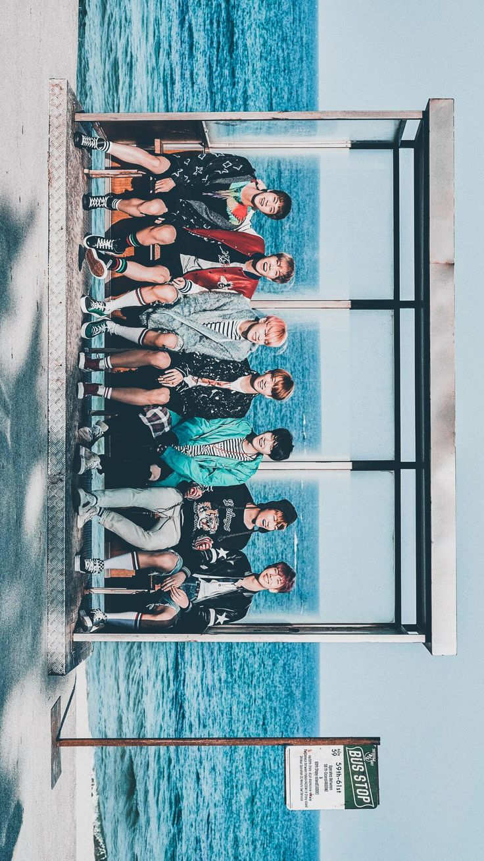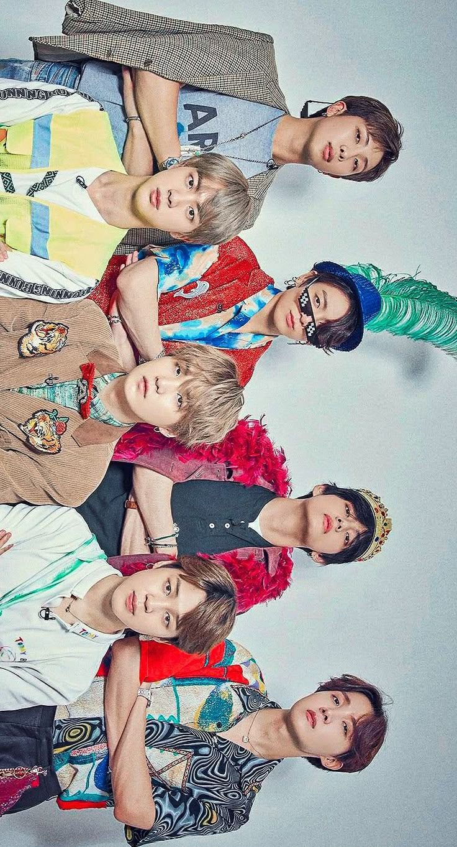 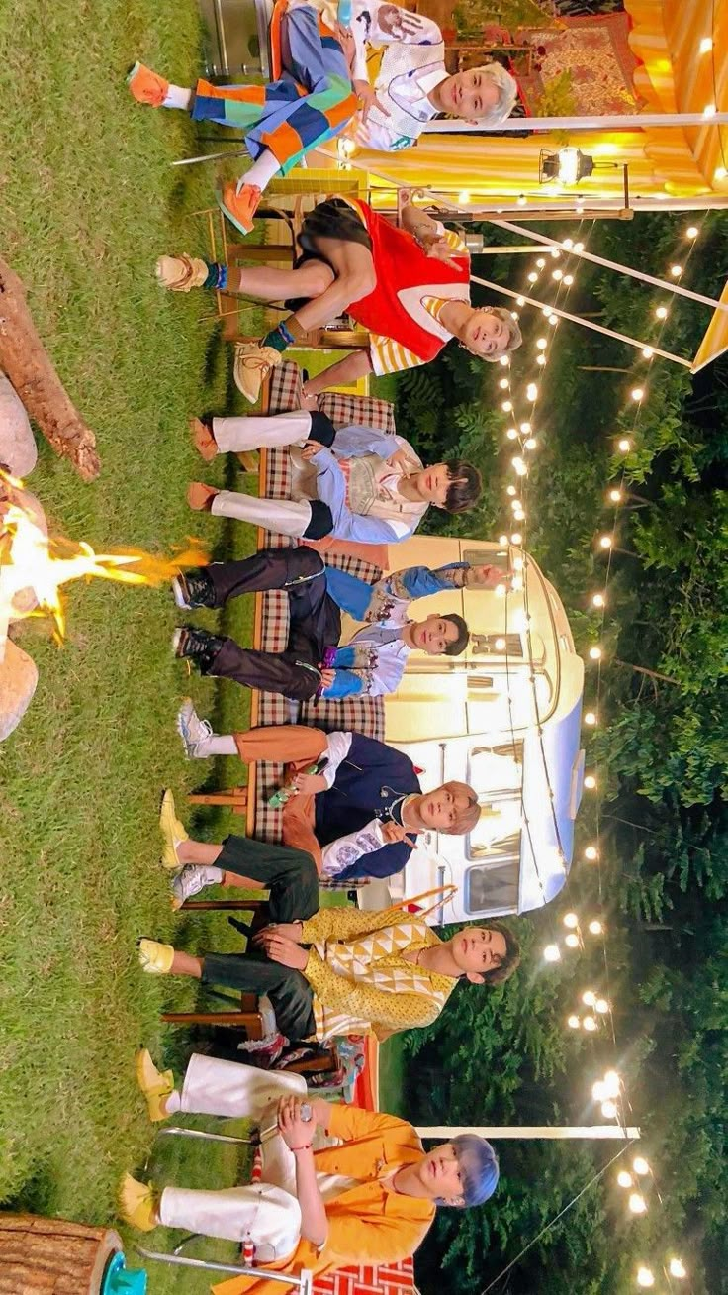 THE MEMORIES NEVER END
Years will pass, seasons will change, and life will take each of them to different places. But the laughter captured in those little moments will always remain.
The silly arguments, the unexpected hugs, the shared meals, the late-night conversations, the playful competitions, and the seven voices laughing together – these are the memories that make BTS feel more than just a music group.
We may have discovered them through their songs, but we stayed for the people behind the music.
And perhaps, one day, when we look back at all these memories, we will realise that we were not just watching seven people create beautiful moments.
We were growing up alongside them.
Because the most beautiful moments in life are not always the biggest ones. Sometimes, they are simply the moments spent together.
Seven forever. One beautiful story. Borahae. 💜
FOREVER WE ARE YOUNG

